What is Spring Boot

Spring Boot is a project that is built on the top of the Spring Framework. It provides an easier and faster way to set up, configure, and run both simple and web-based applications.

## Advantages of Spring Boot

* It creates **stand-alone** Spring applications that can be started using Java **-jar**.
* It tests web applications easily with the help of different **Embedded** HTTP servers such as **Tomcat, Jetty,** etc. We don't need to deploy WAR files.
* It provides opinionated '**starter**' POMs to simplify our Maven configuration.
* It provides **production-ready** features such as **metrics, health checks,** and **externalized configuration**.
* There is no requirement for **XML** configuration.
* It offers a **CLI** tool for developing and testing the Spring Boot application.
* It offers the number of **plug-ins**.
* It also minimizes writing multiple **boilerplate codes** (the code that has to be included in many places with little or no alteration), XML configuration, and annotations.
* It **increases productivity** and reduces development time.

## Limitations of Spring Boot

Spring Boot can use dependencies that are not going to be used in the application. These dependencies increase the size of the application.

Goals of Spring Boot

The main goal of Spring Boot is to reduce **development, unit test,** and **integration test** time.

* Provides Opinionated Development approach
* Avoids defining more Annotation Configuration
* Avoids writing lots of import statements
* Avoids XML Configuration.

By providing or avoiding the above points, Spring Boot Framework reduces **Development time, Developer Effort,** and **increases productivity**.

**Spring Boot Framework** is widely used to develop **REST APIs**.

Spring boot is based on Spring framework.  
spring mvc for web applications like single where as spring boot is sping powered as it can take many module as service.

So lets go with Spring Boot first

# **Spring Boot Architecture**

Spring Boot is a module of the Spring Framework. It is used to create stand-alone, production-grade Spring Based Applications with minimum efforts. It is developed on top of the core Spring Framework.

Spring Boot follows a layered architecture in which each layer communicates with the layer directly below or above (hierarchical structure) it.

Before understanding the **Spring Boot Architecture**, we must know the different layers and classes present in it. There are **four** layers in Spring Boot are as follows:

* **Presentation Layer**
* **Business Layer**
* **Persistence Layer**
* **Database Layer**

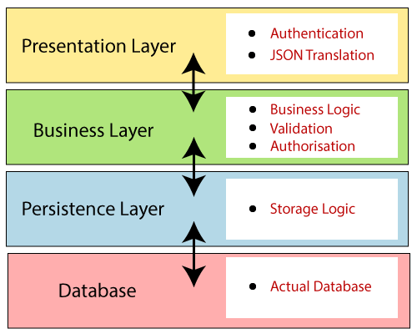

**Presentation Layer:** The presentation layer handles the HTTP requests, translates the JSON parameter to object, and authenticates the request and transfer it to the business layer. In short, it consists of **views** i.e., frontend part.

**Business Layer:** The business layer handles all the **business logic**. It consists of service classes and uses services provided by data access layers. It also performs **authorization** and **validation**.

**Persistence Layer:** The persistence layer contains all the **storage logic** and translates business objects from and to database rows.

**Database Layer:** In the database layer, **CRUD** (create, retrieve, update, delete) operations are performed.

## Spring Boot Flow Architecture

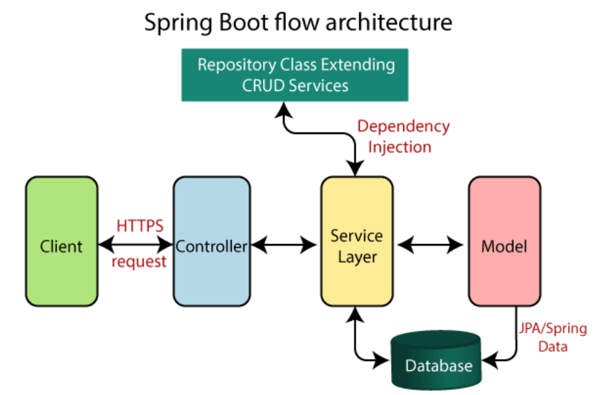

* Now we have validator classes, view classes, and utility classes.
* Spring Boot uses all the modules of Spring-like Spring MVC, Spring Data, etc. The architecture of Spring Boot is the same as the architecture of Spring MVC, except one thing: there is no need for **DAO** and **DAOImpl** classes in Spring boot.
* Creates a data access layer and performs CRUD operation.
* The client makes the HTTP requests (PUT or GET).
* The request goes to the controller, and the controller maps that request and handles it. After that, it calls the service logic if required.
* In the service layer, all the business logic performs. It performs the logic on the data that is mapped to JPA with model classes.
* A JSP page is returned to the user if no error occurred.